The United Kingdom

In 2014 the UK bioeconomy added 250 billion pounds of output to the United Kingdom’s economy and is worth 22 billion pounds of Gross Value Added. The United Kingdom is competitive with other nation’s bioeconomies. They are ranked second on the Global Innovation Index behind Switzerland and were found to produce the fourth highest number of cited scholars throughout all scholarly journals published (evidencing bioeconomies). This is cited as a comparative advantage over other European countries according to Evidencing the Bioeconomy. The majority of the data available is not current, however there are goals and strategies in place built to be achieved by 2025, 2030, and 2050. The UK’s bioeconomy has grown from investment from the private sector. The UK has set four main goals:
- Continue to advance research and development
- Maximizing productivity, increasing productivity from pre-existing renewable resources
- Delivering benefits, wants to double the size of impact of bioeconomy by 2030, increase the amount of jobs created and productivity
- Creating right market conditions, raise public interest, increase the amount of skills in the workforce that contributes to the growth of the bioeconomy

Rather than creating policies the government has published strategies to develop and grow the bioeconomy. The strategies that are essential to the growth of the bioeconomy are The Clean Growth Strategy, Chemistry Council Strategy, Life Sciences Strategy, and UK Industrial Strategy.
The private sector is not the sole responsible actor for the growth of the bioeconomy. The UK has made collaboration between sectors a priority during development, resulting in the IBioIC or Industrial Biotechnology Innovation Center. The Scotland based center brings together academics, scientists, businesses, and government to share ideas and work together on industrial biotechnology projects (IBioIC).
The United Kingdom is already seeing their bioeconomy in action. Chemicals in the cosmetic and pharmaceutical industry are replaced by microbes, while in the packaging industry they are replaced by bio-based alternatives in order to reduce the amount of single use plastic within the UK. Clean energy is becoming more common resulting from a major goal outlined in the Clean Growth Strategy. The UK plans to accelerate clean growth while identifying where the emissions are coming from and the amount each category produces. If fully clean energy is unattainable then energy efficiency must be a priority according to the Energy Performance Certificate (EPC).

The UK | Summary | Related files
Incentives/goals | - Advancement of research and development  - Increased productivity from pre-existing renewable resources  - Double the size of the bioeconomy’s impact by 2030  - Increase skills in the workforce that pertain to the bioeconomy | Growing the bioeconomy
Policies | Strategies used instead of concrete policies  - Clean growth strategy  - Chemical council strategy  - Life sciences strategy  - UK Industrial strategy | Evidencing the bioeconomy
Jobs | - Manufacturing  - Chemicals  - Architecture  - Agriculture  - 5 million jobs added to UK economy from bioeconomy | Growing the bioeconomy
Revenue | - Bioeconomy is worth 22 billion pounds of Gross Value Added | Growing the bioeconomy

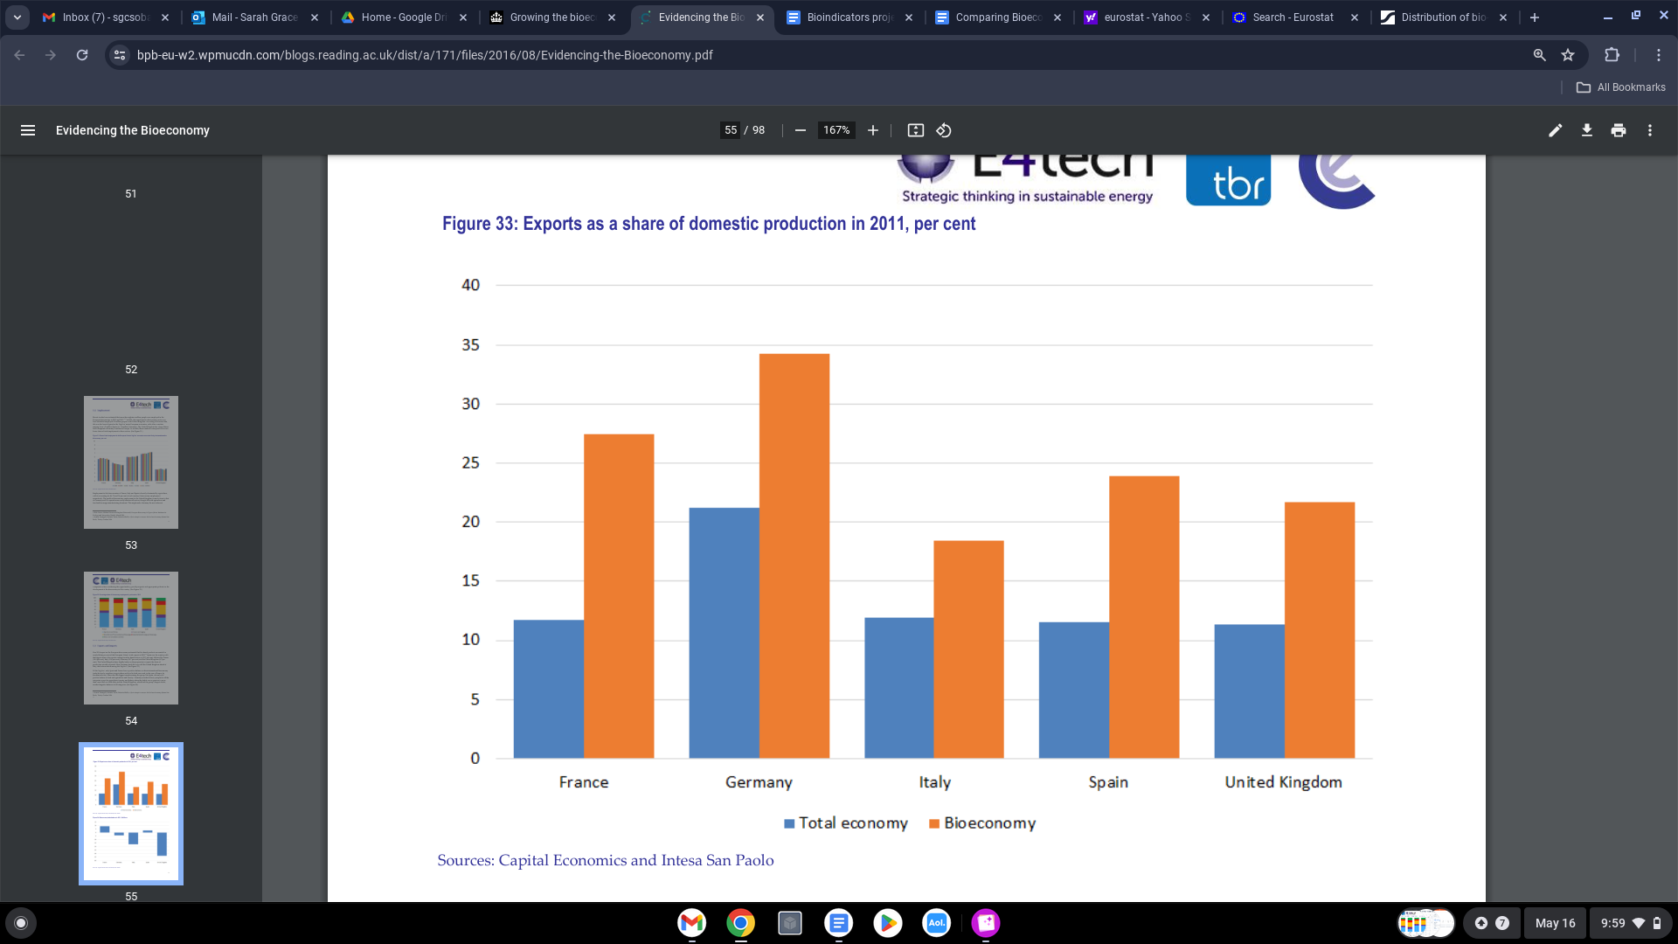

Table found from https://bpb-eu-w2.wpmucdn.com/blogs.reading.ac.uk/dist/a/171/files/2016/08/Evidencing-the-Bioeconomy.pdf
Retrieved May 16th, 2024.
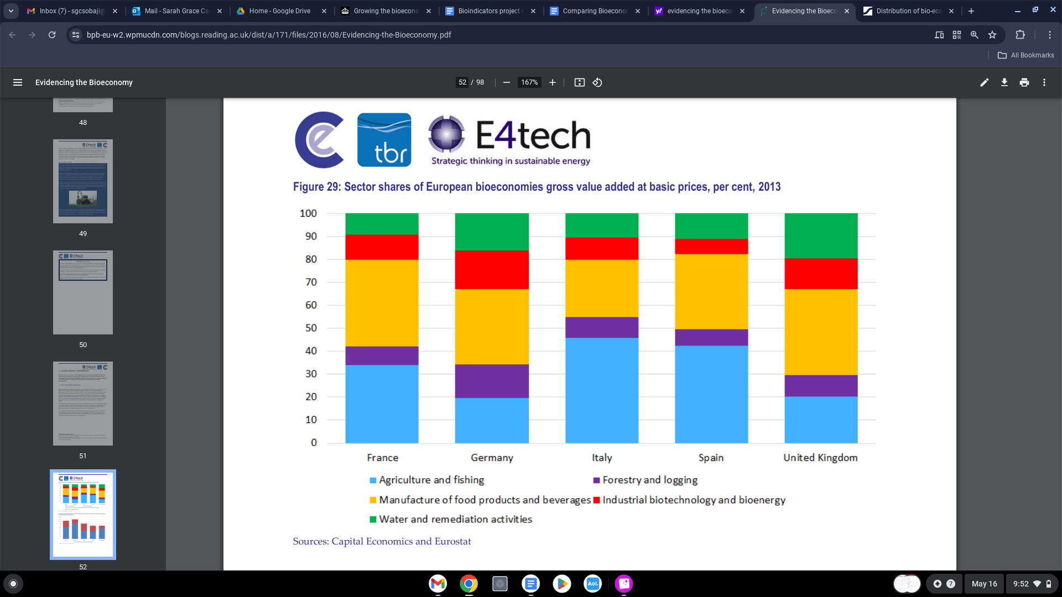

Table found from https://bpb-eu-w2.wpmucdn.com/blogs.reading.ac.uk/dist/a/171/files/2016/08/Evidencing-the-Bioeconomy.pdf
Retrieved May 16th, 2024.
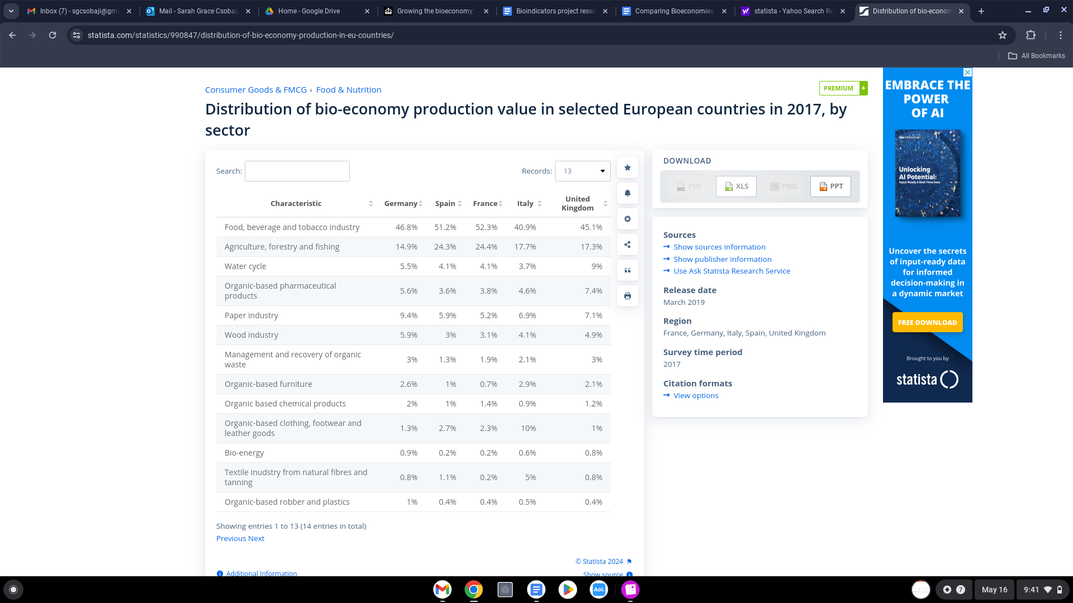

Table found from https://www.statista.com/statistics/990847/distribution-of-bio-economy-production-in-eu-countries/ retrieved May 16th, 2024.

*unable to download data as a PDF because I am not connected to Syracuse University wifi. Statista requires personal devices to be connected to the institution’s wifi in order to properly retrieve data.

Sources

https://bpb-eu-w2.wpmucdn.com/blogs.reading.ac.uk/dist/a/171/files/2016/08/Evidencing-the-Bioeconomy.pdf

https://assets.publishing.service.gov.uk/media/61a60c91d3bf7f055b2934cf/181205_BEIS_Growing_the_Bioeconomy__Web_SP_.pdf

https://assets.publishing.service.gov.uk/media/5ad5f11ded915d32a3a70c03/clean-growth-strategy-correction-april-2018.pdf

https://www.statista.com/statistics/990847/distribution-of-bio-economy-production-in-eu-countries/

